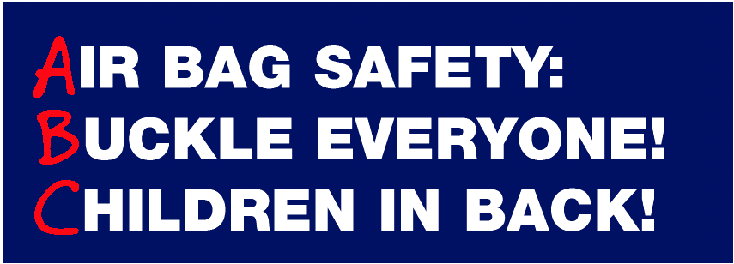
Air bags save lives. They work best when everyone is buckled and children are properly restrained in the back seat. Children riding in the front seat can be seriously injured or killed when an air bag comes out in a crash. An air bag is not a soft, billowy pillow. To do its important job, an air bag comes out of the dashboard at up to 200 miles per hour – faster than the blink of an eye. The force of an air bag can hurt those who are too close to it. Drivers can prevent air bag-related injuries to adults and children by following the critical safety points on the back.
Child Safety Points
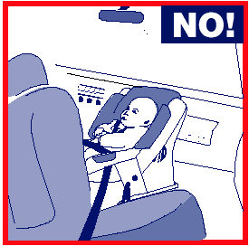

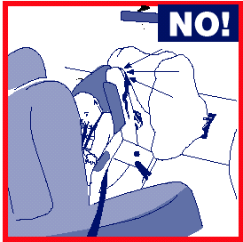

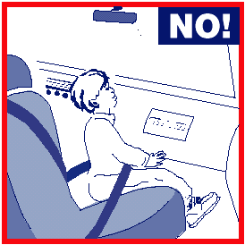

- Children 12 and under should ride buckled up in a rear seat.
- Infants in rear facing child safety seats should NEVER ride in the front seat of a vehicle with a passenger side air bag.
- Small children should ride in a rear seat in child safety seats approved for their age and size .
- If a child over one year old must ride in the front seat with a passenger side air bag, put the child in a front facing child safety seat, a booster seat, or a correct fitting lap/shoulder belt-- AND move the seat as far back as possible.
Adult Safety Points
- Everyone should buckle up with both lap and shoulder belts on every trip. Air bags are supplemental protection devices .
- The lap belt should be worn under the abdomen and low across the hips. The shoulder portion should come over the collar bone away from the neck and cross over the breast bone. The shoulder belt in most new cars can be adjusted on the side pillar to improve fit.
- Driver and front passenger seats should be moved as far back as practical, particularly for shorter statured people.
